**RU Parking**

**ANDROID-BASED APPLICATION FOR SUGGESTING PARKING SPACES**

<http://code.google.com/p/ruparking/>

**REQUIREMENTS ANALYSIS**

**Project Members:**

**Cyrus Gerami**

**Ashwin Revo**

**Shweta Sagari**

**Samson Sequeira**

**Vrajesh Vyas**

Contents

**1. Introduction**

**1.1 Purpose of the System**

**1.2 Scope of the System**

**1.3 Objectives & success criteria**

**1.4 Definitions, acronyms and abbreviation**

**1.5 References**

**2. Current system**

**3. Proposed system**

**3.1 Overview**

**3.2 Functional Requirements**

**3.3 Non-functional Requirements**

**3.4.System Model**

**3.4.1 Scenarios**

**3.4.2 Use Cases**

**3.4.3 User Interface—navigational paths and screen mock- ups**

1. Introduction

# 1.1 Purpose of the System

The number or vehicles on our roads is increasing day by day. However, the city infrastructure is failing to maintain the same growth rate. In large metropolitan cities this has led to a disastrous parking situation. There is a scarcity of street parking spots and an abundance of unhappy commuters. There are navigation systems which direct users to a particular destination and even indicate traffic congestion. But there are no reliable and convenient applications which assist users in finding vacant parking spots.

Our application is intended to fill this void. It is designed to be run on mobile phones making it very accessible. This application will assist the user in finding vacant parking spaces by employing real-time assessments of the parking scenario based upon statistical analysis of current and historical data.

# 1.2 Scope of the System

* All users should be able to access the RUparking application on an Android OS based mobile phone that has GPS and Internet connectivity.
* The application should be able to access the Remote Server to obtain real-time parking decisions.
* This application will also be using the location framework and Google maps external library.

# 1.3 Objectives and success criteria

* Provide a GUI for the mobile user enabling him to find convenient vacant parking spaces.
* Equip the GUI with a map of colored streets, the color indicating the likelihood of having vacant parking spaces.
* Provide the Garage owner with data about parking availability to enable him to set pricing for accordingly.

# 1.4 Definitions, acronyms and abbreviations

**Android OS:** Android is a mobile operating system running on the Linux kernel. It allows developers to write managed code in the Java language, controlling the device via Google-developed Java libraries.

**Mobile User:** End user, which runs this application on a mobile phone, with personal interest.

**Garage Owner:** the owner of any parking garage, which uses this application for evaluation and analysis of block by block parking availability.

**Remote Server:** the server/Database, which provides a decision/suggestion based on raw data.

**Destination Address:** the address where the user would like to find out the parking availability situation. (most probably the trip destination)

**Parking Space:** any segment of a street offering more than three side-parking spots.

**GPS:** Global Positioning System, used for gathering user current coordinates

**SDK:** Software Development Kit, a set of development tools that allows us to create applications for a certain software package.

**GUI:** Graphical User Interface, a type of user interface, which allows people to interact with electronic devices such as mobile phones. A GUI offers graphical icons, and visual indicators, typed command labels or text navigation to fully represent the information and actions available to a user.

# 1.5 References:

1. <http://developer.android.com/guide/index.html>
2. <http://code.google.com/apis/maps/documentation/index.html>
3. <http://www.parc.com/event/935/sensor-networks-in-the-big-city.html>
4. <http://primospot.com/>
5. Current System

Currently the park space applications in the market base their decisions on static information about the parking spaces. These applications maintain a database of the legal spaces and their restrictions like parking hours, duration of parking etc. Such a system is inefficient since it is not able to suggest parking spaces based on its current state. There are applications that claim to identify vacant parking spaces in real-time by connecting sensors to the parking meters. Such a system requires large-scale changes in the existing infrastructure, which is not financially feasible. Also it is not applicable for street-side parking that provides for majority of the parking spaces in metropolitan cities. Also these parking spaces are usually metered in which case they are occupied by one vehicle for a short time like two hours. So there is a need to identify the vacancies in these parking spaces in real-time. Since these spaces do not have sensors this has not been achieved so far. Our Application tries to accomplish this using the real-time data provided by the Roadside Parking Monitoring team.

1. Proposed System

# 3.1 Overview

Our project aims to provide a user-friendly Graphical User Interface (GUI) that can be used on smart phones that run on the Android OS. The RU Parking Application will provide the user real-time decisions on where vacant parking spaces are present. It interacts with a Remote Server to obtain the parking information. Once this information is received by the application it will display this information in an easy-to-understand way to the user. It provides the user with 3 different levels of map detail to enable him to make different types of decisions regarding parking and commuting. This application will also provide the option to the user to be directed to a particular parking space by navigating him there turn-by-turn.

In addition to the Mobile User, this application also caters to the Garage Owners. These users are provided with the list that captures the parking situation around their garage. The Garage Owners can choose the radius of the area around them, about which they want to obtain information.

# 3.2 Functional Requirements:

# RU parking is a mobile application that provides real time information about park space availability to the user. The application supports two types of users:

# The mobile user should be able to access parking information for any location. This information is provided in form of maps showing colored streets. The mobile user should be able to choose between three views namely area view, block view and street view. The mobile user will also be able to select one particular parking space and obtain the routing information for that selection.

# The garage owner should be able to access list of parking spaces in a given radius along with timing information. The user should be able to change the radius under consideration.

# 3.3 Nonfunctional Requirements:

# Usability: The user must be able to utilize this application without any prior knowledge about the user interface. The interface must allow the user to work with the different features of application with a maximum of four clicks. In case of any issues, the user must be able to find the solution by referring to the user manual.

# Reliability: This application depends on the Internet and GPS connectivity. In case of loss of Internet connectivity this application will use the last information fetched from the remote server to display parking information. In case of GPS failure the user can input the address manually, in the destination address text box. In the event of application crashing it should be able to restart automatically displaying last confirmed output to the user.

# Performance: The application will support one instance per phone. After the user inputs the destination address, the output should be given within 30 seconds.

# Supportability: The application should be compatible with any future changes in the remote server provided the data format remains the same. The user should be able to upgrade the maps on the phone without re-installing the software. This procedure will require restarting of application.

* **Implementation:** All users should be able to access RU parking on their android based mobile phones supporting GPS and internet. Additionally users having an Internet connection should also be able to access RU parking through a web interface.
* **Interface**: The application interfaces with a remote server to access real time parking space information. The data in the remote server is stored in a tabular form having the latitude, longitude, the current state of parking space and the time of reading as attributes. This information is exchanged over the Internet.

# Operation: The application should connect to a remote server over the Internet to send the destination address and use the information given by the server to display the output on the phone.

# Legal: The developers are not responsible for incorrect parking information since this information is sourced from third party vendors. The connection between the application and the server is encrypted to safeguard user privacy. No user information is stored on the remote servers and information regarding the user location is not provided to any third party vendors.

# 3.4 System models:

### 3.4.1 Scenarios:

|  |  |
| --- | --- |
| Scenario name | currentLocationParking |
| Participating actor instances | bob: MobileUser |
| Flow of event | 1. Bob is driving towards his office to attend an important meeting, when he reaches his destination he is unable to find a parking space.  2. He activates RU parking application on his phone.  3. He selects "current location" option in the application.  4. This request is sent to the server that responds with an updated map showing colored streets with available parking spaces.  5. Bob refers to this map and can observe the nearest parking spaces. |

*Figure 3-1 The currentLocationParking scenario for the ViewMap use case.*

|  |  |
| --- | --- |
| Scenario name | destinationParking |
| Participating actor instances | bob: MobileUser |
| Flow of event | 1. Bob is about to leave for a football match. There are 3 streets through which he can reach the stadium. He wants to know beforehand on which street there is a higher probability of finding a parking space.  2. He activates RU parking application on his phone.  3. He enters "destination address" in the application.  4. This request is sent to the server which responds with an updated map showing colored streets with available parking places.  5. Bob refers this map and can observe the street which has higher probability of having parking places. |

*Figure 3-2 The destinationParking scenario for the ViewMap use case.*

|  |  |
| --- | --- |
| Scenario name | routeProvider |
| Participating actor instances | bob:MobileUser |
| Flow of event | 1. Bob is visiting his friend after a long time and does not know the way; moreover his friend informed him that there are no parking spaces around his apartment.  2. He activates RU parking application on his phone.  3. He enters "destination address" in the application.  4. This request is sent to the server which responds with an updated map showing colored streets with available parking places near that area.  5. Bob refers this map, selects a particular street and also clicks on the route option, which guides Bob to a parking space near his friend’s place. |

*Figure 3-3 The routeProvider scenario for the SelectNavigation use case.*

|  |  |
| --- | --- |
| Scenario name | parkingRates |
| Participating actor instances | tom:GarageOwner |
| Flow of event | 1. Tom is an intelligent garage owner who changes the parking rates as per the parking space availability. But he is unaware of the parking space availability in neighboring streets.  2. He activates RU parking application on his phone.  3. He enters "garage address" in the application.  4. This request is sent to the server, which responds with an updated list of streets with parking space availability and the timings associated with that information.  5. Tom refers to this map and decides on the parking rates. |

*Figure 3-4 The parkingRates scenario for the ViewStatistics use case.*

### 3.4.2 Use Cases

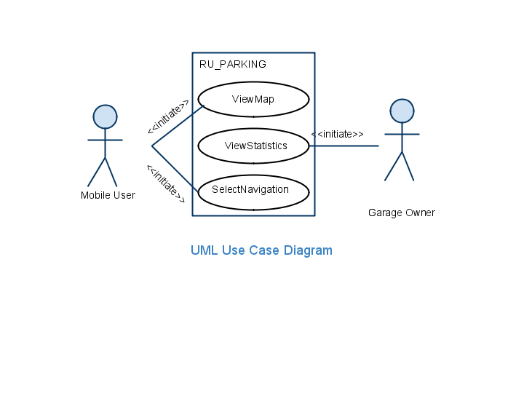

*Figure 3-5 High-level use cases for RU Parking*

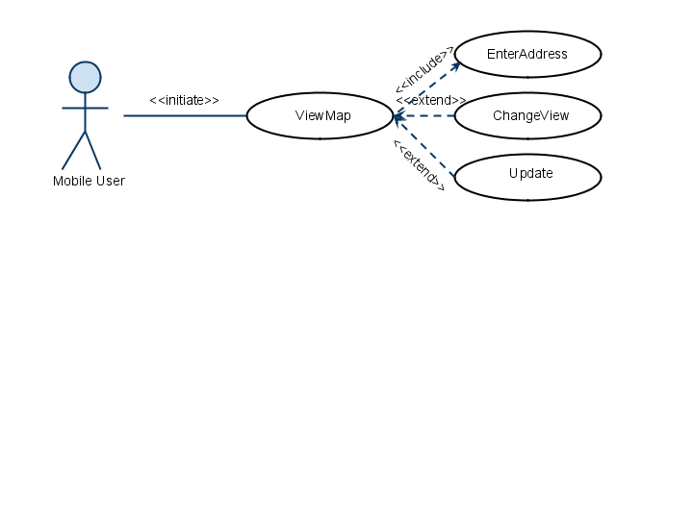

*Figure 3-6 Detailed use cases refining the ViewMap high-level use case.*

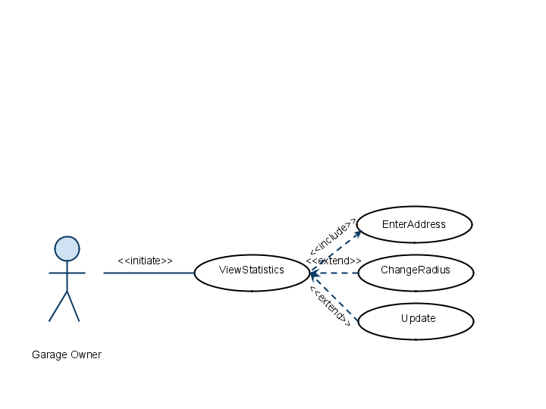

*Figure 3-7 Detailed use cases refining the ViewStatistics high-level use case.*

|  |  |
| --- | --- |
| Use case Name | ViewMap |
| Participating Actors | Initiated by Mobile User  Communicates with InputAddress, ChangeView and Update |
| Entry Condition | 1. Mobile User inputs the address in the application. |
| Flow of Events | 2. Application displays the parking scenario map in default detail level. Availability of parking space is shown using a color code; the color indicating the likelihood of parking availability.  3. Options available to the user are-  a) Exit from application  b) Change map view detail level  c) Select the navigation mode for the desired location  d)Update data  4. Chosen option is used as an input to the application |
| Exit Condition | 5. Exit condition depends on the option chosen by the Mobile User  a) 'Exit' - Application is closed  b) 'ViewMap' and 'SelectNavigation' - Current Window is navigated to a new window relative to the option.  c) ‘Update’ reloads the same window with new data |
| Quality Requirements | 1. Parking suggestion should be in real-time and accurate. |

*Figure 3-8 The ViewMap use case description.*

|  |  |
| --- | --- |
| Use case Name | ViewStatistics |
| Participating Actors | Initiated by Garage Owner  Communicates with InputAddress, ChangeView and Update |
| Entry Condition | 1. Garage Owner inputs the address in the application. |
| Flow of Events | 2. Application displays the parking scenario statistics for the default area size. It consists of a list showing the streets within the area and their parking availability  3. Options available to the user are-  a) Exit from application  b) Change area size  4. Chosen option is used as an input to the application |
| Exit Condition | 5. Exit condition depends on the option chosen by the Garage Owner  a) 'Exit' - Application is closed  b) 'ViewMap' and 'SelectNavigation' - Current Window is navigated to a new window relative to the option.  c) ‘Update’ reloads the same window with new data |
| Quality Requirements | 1. Parking suggestion should be in real-time and accurate. |

*Figure 3-8 The ViewStatistics use case description.*

|  |  |
| --- | --- |
| Use case Name | SelectNavigation |
| Participating Actors | Initiated by Mobile User |
| Entry Condition | 1. The Mobile User clicks on a location on the map |
| Flow of Events | 2. A window pops up showing address of the street and with the option to navigate to the selected location  3. Clicking the 'Navigate' option is taken as input to the application |
| Exit Condition | 4. Current window is navigated to a new window in which the route to destination is highlighted and the user is provided with visual and audio directions. |
| Quality Requirements | System should respond within 15 seconds and start directing Mobile User. |

*Figure 3-9 The SelectNavigation use case description.*

|  |  |
| --- | --- |
| Use case Name | EnterAddress |
| Participating Actors | Initiated by Mobile User and Garage Owner |
| Entry Condition | 1. Starting the RU parking application |
| Flow of Events | 2. Two options are displayed - 'Current Location' and 'Destination Address'  3. The user selects one of the options  4. When user chooses 'Destination Address', a new window is opened. User inputs the destination address and this is taken as input by the system.  5. If the user chooses 'Current Location', the user's location is taken as input by the system |
| Exit Condition | 6. Current window is navigated to a new window showing a map or a list depending on the type of user. |
| Quality Requirements | System should display the parking information within 15 seconds. |

*Figure 3-10 The EnterAddress use case description.*

|  |  |
| --- | --- |
| Use case Name | ChangeView |
| Participating Actors | Initiated by Mobile User |
| Entry Condition | 1. Mobile User chooses 'Change View' option from default map detail |
| Flow of Events | 2. 'ChangeView' options –   * Street View * City View   3. When selected any one option, view detail is changed to the other level  4. Other available options -  a) 'Exit' - exit from application  b) 'Select Navigation' - select the navigation mode for selected location |
| Exit Condition | 5. Exit condition depends upon option chosen by mobile user  a) 'Exit' - Application is closed  b) 'ChangeView' and 'Select Navigation' - Current Window is navigated to a new window relative to the option |
| Quality Requirements | Details of parking space should change according to the selected option within 10 seconds. |

*Figure 3-11 The ChangeView use case description.*

|  |  |
| --- | --- |
| Use case Name | ChangeRadius |
| Participating Actors | Initiated by Garage Owner |
| Entry Condition | 1. Garage Owner chooses 'ChangeRadius' option from default area details |
| Flow of Events | 2. 'ChangeRadius' options –   * Increase Radius * Decrease Radius   3. When selected any one option, the statistics are displayed according to the area size chosen.  4. Other available options -   * 'Exit' - exit from application |
| Exit Condition | 5. Exit condition depends upon option chosen by mobile user  a) 'Exit' - Application is closed  b) 'ChangeRadius' - Current Window is navigated to a new window displaying statistics relative to the area chosen |
| Quality Requirements | Details of parking space should change according to the selected option within 10 seconds. |

*Figure 3-12 The ChangeRadius use case description.*

|  |  |
| --- | --- |
| Use case Name | Update |
| Participating Actors | Initiated by Mobile User and Garage Owner |
| Entry Condition | 1. The user clicks on the ‘Update’ option so that he can obtain current data |
| Flow of Events | 2. The application obtains new parking information from the Remote Server and refreshes the screen to display the new information |
| Exit Condition | 3. The use case exits when the application has refreshed the screen. |
| Quality Requirements | System should respond within 15 seconds along with the new information |

*Figure 3-13 The Update use case description.*

# 3.4.3 User Interface—navigational paths and screen mock-ups:

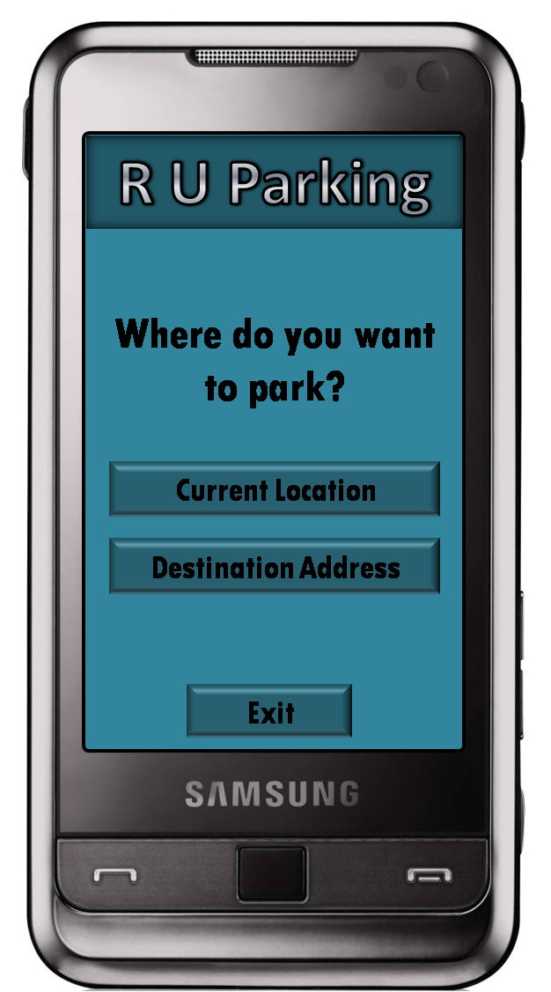 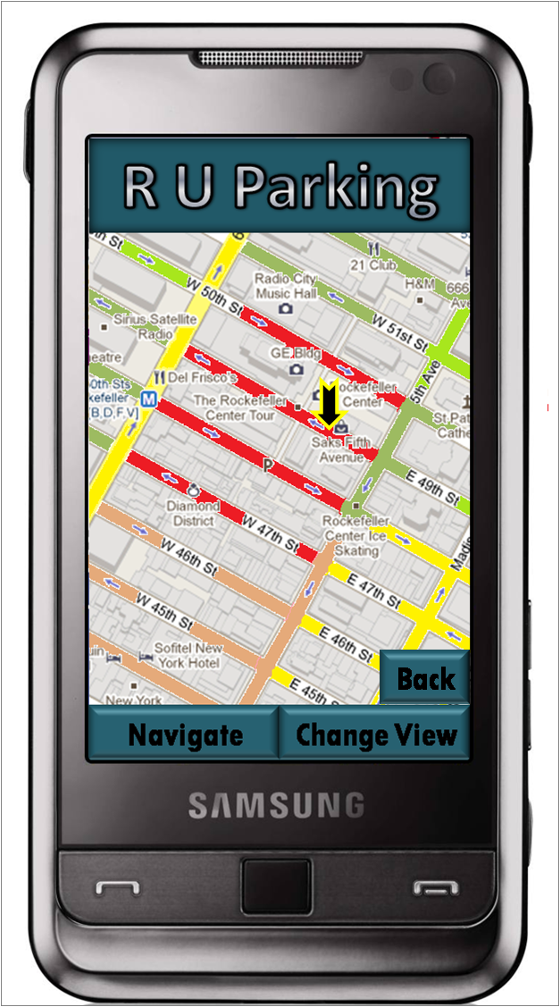

*Figure 3-14 The Screen mock-ups for RU Parking.*

The RU Parking Application users are provided with a user-friendly and convenient Graphical User Interface. It is important that the GUI is easy to use and gives only relevant details so as to not distract the user or take more time to understand.

The first screen of the GUI gives the user the option of choosing where he wants to park; at his current location or some other address.Once the application has figured out the user’s required parking location, the GUI shows the map of that location and relevant parking information. The availability of parking is illustrated using colors which makes it very readable. The GUI also provides options for changing the level of detail in the map. It also offers visual directions when the user opts for the Navigation mode. The Garage Owner will be provided with a list of statistics and the option to choose the area about which he needs information.